Homework Eight
Part 1.
For each sentence, identify the optional adverbial by underlining it. Then, rewrite the optional sentence with the optional adverbial in a different place.
Example:
- During World War II the government required large amounts of copper for war production.
- The government required large amounts of copper for war production during World War II.
- Early Lincoln pennies are very valuable today.
  - Today, early Lincoln pennies are very valuable.
- In 1943 zinc-coated steel replaced the copper in the production of pennies.
  - Zinc-coated steel replaced the copper in the production of pennies in 1943.
- The copper blanks for those twelve pennies were still in the press hopper during the production of the zinc-coated coins.
  - During the production of the zinc-coated coins, the copper blanks for those twelve pennies were still in the press hopper.
- Even after 100 years, the production of the Lincoln penny continues today.
  - Today, even, the production of the Lincoln penny continues, and I love that after 100 years.
Part Two
For each of the sentences on the following pages, I have identified the sentence pattern for you. Use that information to complete the following three tasks.
- Complete the labeling tables by adding the part of speech and the phrase type.
- For each sentence, I have listed the key components that help determine what sentence pattern it is. For each key component, write out the full phrase filling that role (not just the headword, but the whole phrase).
- Draw a tree diagram of the sentence. You can find examples of syntactic trees for each type in my Sentence Pattern Handout. Feel free to draw you diagrams by hand and bring them to class or make them digitally and submit through Canvas.
See an example on the next page…

Example: Curiously, the paper called the mayor a negligent politician.
Pattern: Ditransitive with Direct Object and Object Complement
ROLES | Advl | Subj |  | Pred | DO |  | Obj Comp
Phrase | ADVP | NP |  | VP | NP |  | NP
Word | Curiously, | The | paper | called | the | mayor | a | negligent | politician
Part of Speech | Adv | Det | N | V | Det | N | Det | Adj | N
- Direct Object: The Mayor
- Object Complement: A Negligent Politician
- Optional Adverbial: Curiously
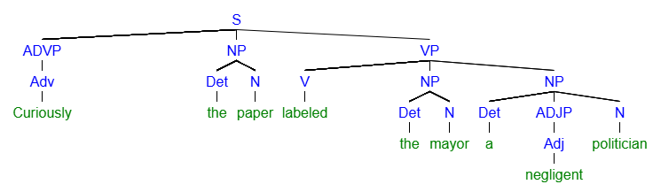

  - The students in my class are extremely sleepy.
Sentence Pattern: “Copular Be”
ROLES | Subj |  |  |  |  | Pred | Subj Comp
Phrase | NP |  |  |  |  | VP | ADJP
Word | The | Students | In | My | Class | Are | Extremely | Sleepy
Part of Speech | Det | N | Prep | Det | N | V | Adv | Adj
- Identify the Subject Complement: “Extremely Sleepy”
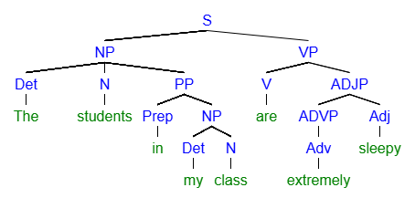

My friend looked very sad on Monday.
Sentence Pattern: Linking Verb
 | Subj |  | Pred | Subj Comp |  | Advl
Phrase | NP |  | VP | ADJP |  | PP
Word | My | Friend | Looked | Very | Sad | On | Monday
Part of Speech | Det | N | V | Adv | Adj | Prep | N
- Identify the Subject Complement: Very Sad
- Identify the Optional Adverbial: On Monday
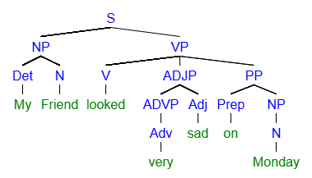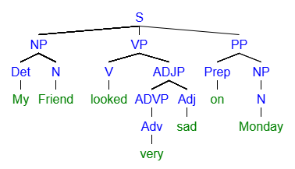

4. The cat ate his dinner on the porch.
Sentence Pattern: Transitive with Direct Object
Phrase | NP |  | VP | NP |  | PP
Word | The | cat | ate | his | dinner | on | the | porch
Part of Speech | Det | N | V | Det | N | Prep | Det | N
- Identify the Direct Object: His Dinner
- Identify the Optional Adverbial On The Porch
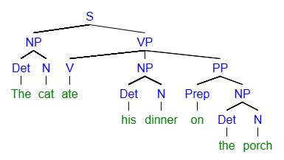

5. Kevin sent his elderly mother a present.
Sentence Pattern: Ditransitive with Direct Object and Indirect Object
Phrase | NP | VP | NP |  |  | NP
Word | Kevin | sent | his | elderly | mother | a | special | present
Part of Speech | N | V | Det | Adj | N | Det | Adj | N
- Identify the Direct Object: a special present
- Identify the Indirect Object: his elderly mother
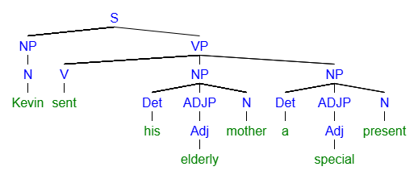

6. In truth, Pip considered Ms. Haversham a monster.
Phrase | PP |  | NP | VP | NP | NP
Word | In | Truth | Pip | Considered | Ms Haversham | a | Monster
Part of Speech | Prep | N | N | V | N | Det | N
- Identify the Direct Object: Ms. Haversham
- Identify the Object Complement: A Monster
- Identify the Optional Adverbial: In Truth
